Documenting the Architecture - Guidelines

General
Note: This document provides a set of guidelines to follow for documenting your system architecture in your Architecture Design Specification (ADS). This guideline document is not a template that you should replicate and complete, but it can be used as the basis for construction of your document. That is, the section numbering and naming used herein is a reference for the content of the Architecture Design Specification Document, NOT the structure of the ADS.
Your architecture defines how the system/product will be constructed, describing what the critical components are and how they fit together, from a high-level, logical perspective. It does not provide the details of your design – that comes later. Your architecture must be documented in a way that clearly states the identification of the logical layers of your system, the specific subsystems that compose the layers, and their responsibilitiesand interfaces.
While an architectural block diagram is a static model of the architecture, we will use an additional model: a data flow-like model based on the architectural block diagram. The next several sections describes the logical organization, representation and content of the architecture specification itself.

Introduction
Your introduction should describe your product concept in sufficient detail that the architectural design will be easy to follow. The introduction may include information used in the first sections of your SRD for this purpose. At a minimum, ensure that the product concept, scope and key requirements are described.

Meta Architecture
[Specify in this section your architectural vision, key principles, special styles/conventions to be followed, concepts and key assumptions that will affect how you will go about designing the product. Focus on the high-level decisions that will strongly influence the structure of the system. This section should rule out certain structural choices, and guide your decisions and tradeoffs among others.]

Architectural Vision

Guiding Principles

Modularity
Modularity is a key guiding principle for the 3-D Printer Fabrication System because of the many different implementations of 3-D model processing as well as many possible printer hardware configurations. Therefore, the architectural design of the system takes a modular approach. The layers of the system are loosely coupled, allowing the implementation of each layer to be easily replaced by a different implementation. This also means that modules within each layer maintain high cohesion with one another. In order to achieve this loose coupling, the interfaces between layers are thoroughly defined so that any implementation of a layer knows exactly what type of input to expect and what type of output to create.

Configurability
The current state of 3-D printing relies heavily on the user’s ability to properly configure each print job according to the object being printed and the printer hardware used for the print. This creates a need for configurability within the 3-D Printer Fabrication System. The architecture of the system allows print job and printer variables to be configured directly by the user. This means that the architecture exposes an interface to the user from which he or she can configure any data needed by the system to perform its processing functions.

Extensibility
Support for printing multiple materials within a single print job is a new development within 3-D printing. First and foremost, the 3-D Printer Fabrication System is focused on providing this multiple material functionality. Although the initial goals of the system is to provide multiple material support, the system is likely to be extended in the future to become a more fully featured 3-D printing software suite. As such, the architecture of the system is designed to allow future features and functions to be added with minimal integration challenges.

Guidelines for Defining Layers
Each layer of the system should be completely independent of any other layer. Keeping with the guiding principle of modularity defined above, the implementation of any layer should be able to be swapped out with a different implementation as long as the interfaces remain standard. In addition to layer independence, layers should only communicate with the layers directly above or below them. Any communication between layers must use defined inter-layer interfaces.

Guidelines for Defining Subsystems
All subsystems within the same layer must maintain high cohesion with one another. Each subsystem must provide a service that directly supports the functionality of the layer it is contained in. Subsystems must also be loosely coupled with each other, even if they are within the same layer. No subsystem should be directly dependent on another, but rather dependent only on a standardized interface between the subsystems.

Assumptions

Tradeoffs

Layer Definition Section
This section should describe the overall structure of your software system. Think of it as the strategy for how you will build the system. An architectural “layer” is the top-level logical view, or an abstraction, of your design. Layers should be composed of related elements of similar capabilities, and should be highly independent of other layers, but should have very clearly defined interfaces and interactions with other layers. Each layer should be identified individually and should be unique as to its function and purpose within the system. This section should also contain the high-level block diagram of the layers, as shown in the example below, as well as detailed descriptions of the functions of each layer.
Data Capture Layer
Data Processing Layer
User Interface Layer
Data Analysis Layer

Data Access Layer

Hardware Interface Layer

Figure 1.1. An Example of an Architectural Layer Diagram
Note in Figure 1.1 that vertical layers can be used to show availability of services to multiple other layers, as they may provide centralized common services at various levels.

Interface Layer
Each layer should be described separately in detail. Descriptions should include the features, functions, critical interfaces and interactions of the layer. The description should clearly define the services that the layer provides. Also include any conventions that your team will use in describing the structure: naming conventions for layers, subsystems, modules, and data flows; interface specifications; how layers and subsystems are defined; etc.

Pre Processing Layer
Each layer should be described separately in detail. Descriptions should include the features, functions, critical interfaces and interactions of the layer. The description should clearly define the services that the layer provides. Also include any conventions that your team will use in describing the structure: naming conventions for layers, subsystems, modules, and data flows; interface specifications; how layers and subsystems are defined; etc.

Processing Layer
Each layer should be described separately in detail. Descriptions should include the features, functions, critical interfaces and interactions of the layer. The description should clearly define the services that the layer provides. Also include any conventions that your team will use in describing the structure: naming conventions for layers, subsystems, modules, and data flows; interface specifications; how layers and subsystems are defined; etc.

Post Processing Layer
Each layer should be described separately in detail. Descriptions should include the features, functions, critical interfaces and interactions of the layer. The description should clearly define the services that the layer provides. Also include any conventions that your team will use in describing the structure: naming conventions for layers, subsystems, modules, and data flows; interface specifications; how layers and subsystems are defined; etc.

Physical Layer
Each layer should be described separately in detail. Descriptions should include the features, functions, critical interfaces and interactions of the layer. The description should clearly define the services that the layer provides. Also include any conventions that your team will use in describing the structure: naming conventions for layers, subsystems, modules, and data flows; interface specifications; how layers and subsystems are defined; etc.

Inter-Subsystem Data Flow Section
This section breaks down your layer abstraction to another level of detail. Here you grapically represent the logical subsytems that compose each layer and show the interactions/interfaces between those subsystems. A subsystem can be thought of as a programming unit that implements one of the major functions of the layer. It, therefore, has data elements that serve as source/sinks for other subsystems. The logical data elements that flow between subsystems need to be explicitly defined at this point, beginning with a data flow-like diagram based on the block diagram. Following is an example of a data flow diagram, taken from a prior senior design project:
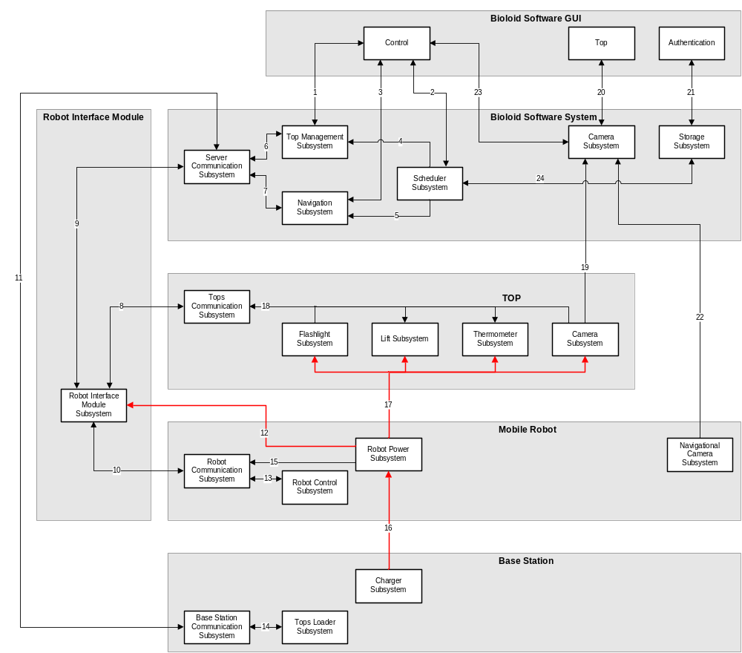
Figure 1.2. An Example of an Architectural Data flow Diagram.
Once the inter-layer data flows have been exposed, each of the elements flowing between layers must be described. This is often best done in a simple tabular form as shown in sample of Table 1.1 below. The specific data elements depicted in the data flow diagram are described in detail in this sub-section. Each named data element is described in terms of its generic type, its use and any other relevant information.

Table 1.1. Sample Inter-Subsystem Data Element Descriptions.
Data Element |  | Descriptions
1. element-a | description of element-a
2. element-b | description of element-b
3. element-c | description of element-c
4. element-d | description of element-d
NOTE: include any specific notes about this table here. This is any additional information about the table that may be necessary to read it properly. This may include notes of omitted information, keys to symbols, etc.
Table Descriptions
Data Element: the name by which the data element is referred to in the rest of the document. Note that the term data element as used above also specifies complex elements such as objects or structures. For example, a data element could be an integer value, a string of characters, or a JPEG graphics object.
Description: a verbal description of the data element. Specify here what the element is in terms of its composition/type, and what it is used for.
Once the elements themselves are described, their actual flow paths should be documented. Because the flow of any element is from producer (source) to consumer (sink), the flows are most easily summarized by the use of a flow path transition matrix, such as:
Table 1.2. Producer-Consumer Relationships.
 | Consumer Subsystem
Producer  Subsystem | Subsystem  a | Subsystem  b | Subsystem  c | Subsystem  d | Subsystem  e
subsystem a |  |  |  | 2.
subsystem b | 1. |  |  | 2.
subsystem c |  |  |  |  | 3.
subsystem d |  |  |  |  | 4.
subsystem e
Table Descriptions
Producer Subsystem: name of the layer or subsystem that creates the data elements specified. Note that this is the layer that invokes the constructor for the data element, not necessarily the layer that owns the constructor.
Consumer Subsystem: name of the layer or subsystem that uses the data elements created by the producer layers.
Table Cells: the intersection of the two layers. At the intersection of the two layers is a list of data element numbers referring to the Inter-Subsystem Data Element Description Table (Table 1.1). Elements listed in the intersection are created by the subsystem or layer on the left and consumed by the subsystem or layer above.

Interface Layer
In this section, the layer is described in some detail in terms of its specific subsystems. Describe each of the layers and its subsystems in a separate chapter/major subsection of this document. The content of each subsystem description should be similar. Include in this section any special considerations and/or trade-offs considered for the approach you have chosen.

General
This section should be a brief recapitulation of the summary of the layer given above. For most subsystems, an extract of the architectural block diagram with data flows is useful. This should consist of the subsystem being described and those subsystems with which it communicates. For example, from Figure 1.2 above, in the introduction of the subsection devoted to the “Scheduler Subsystem,” you would provide a diagram highlighting that subsystem with its data flows to the four other subsystems that it interfaces with.
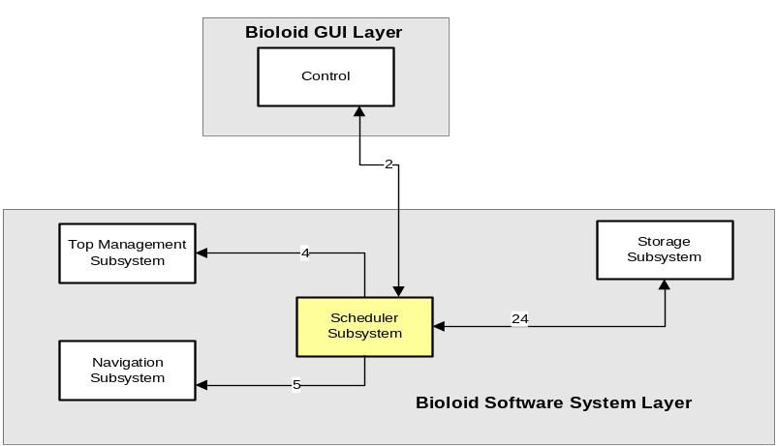
Figure 1.3 Example of Subsystem description diagram

Subsystem Name

Assumptions
Any assumptions made in the definition of the subsystem should be listed and described. Pay particular attention to assumptions concerning interfaces and interactions with other layers.

Responsibilities
Each of the responsibilities/features/functions/services of the subsystem as identified in the architectural summary must be expanded to more detailed responsibilities. These responsibilities form the basis for the identification of the finer-grained responsibilities of the layer's internal subsystems. Clearly describe what each subsystem does.

Subsystem Inter-layer Interfaces
Each on the functions or methods that are exposed to other layers (sources and sinks) should be briefly indentified in a manner similar to Table 1.3.
Table 1.3. Public Interface to Definition Management Layer.
Method | Description | Information  Required | InformationReturned
method-1 | description of method-1 | • input-a | • return-a
 |  | • input-b
method-2 | description of method-2 | • input-c | • return-f
Table description:
Method | name of method or function
Description | brief verbal description of the method
Information Required | a list of the data elements required for the method to operate properly. Analogous to a list of parameters.
Information Returned | the results returned by the method. May be a return code, an object or set of objects, or simply a side effect.

Subsystem Public Interfaces
Each of the functions, methods or interfaces that are exposed to the external world (typically, end users) by a subsystem should be identified and described in a manner similar to inter-layer interfaces discussed immediately above.

Pre-Processing Layer

Subsystem Name

Assumptions

Responsibilities

Subsystem Inter-layer Interfaces

Subsystem Public Interfaces

Processing Layer

Subsystem Name

Assumptions

Responsibilities

Subsystem Inter-layer Interfaces

Subsystem Public Interfaces

Post-Processing Layer

Subsystem Name

Assumptions

Responsibilities

Subsystem Inter-layer Interfaces

Subsystem Public Interfaces

Physical Layer

Subsystem Name

Assumptions

Responsibilities

Subsystem Inter-layer Interfaces

Subsystem Public Interfaces

Printer Feedback Layer

Subsystem Name

Assumptions

Responsibilities

Subsystem Inter-layer Interfaces

Subsystem Public Interfaces

Operating System Dependencies Section
In this section you will define your critical dependencies, interactions and interfaces with any embedded/ancillary operating system that is used by your system. Run-time libraries, classes, etc. should be identified if your architecture is dependent on the services they provide. For example, if you use Linux and are dependent on the IP protocol stack or some of its component in order to provide client server or peer-to-peer communication, that dependency should be described. Or, if you are dependent on specific JAVA run-time class support in Windows for you GUI, describe the dependencies and services required.
[Follow with sections, as described above, for each layer of your architecture.]

Testing Considerations Section
This is NOT your test plan. This chapter addresses how you will verify and validate the architecture that has been specified herein.

General
Describe specifically the approach you will use to validate your architecture. You should address here what must be done to assure that all interfaces and interactions perform as documented. You should also discuss the approach you will use to verify the integrity of your architectural design.
Also, specifically identify any required components or elements that must be designed with test points, hooks, ancillary outputs/inputs that are used for testing only, etc.

